Theory:
Data cleaning is the process of improving data quality by removing errors and inconsistencies. It includes handling missing values, correcting data types, and removing duplicates. Missing values can be treated using mean, median, or mode imputation. Duplicate records are removed to avoid bias. Outlier detection is performed to identify abnormal values. Data transformation ensures consistency across features. Clean data improves model accuracy and reliability. This step is essential before any analysis or modeling. It ensures that the dataset is accurate and usable.

Dataset Description:
The dataset is mostly clean with minimal missing values. It contains numerical features and a date column. Some preprocessing like date conversion is required. The dataset is suitable for cleaning operations.

Program Code:
import pandas as pd
import numpy as np

# Step 2: Load Dataset
df = pd.read_csv('silver_prices_data.csv')

print("\n===== ORIGINAL DATA ====")
print(df.head())

# --------------------------------------------
# Step 3: Check Missing Values
# --------------------------------------------
print("\n===== MISSING VALUES BEFORE CLEANING ====")
print(df.isnull().sum())

# --------------------------------------------
# Step 4: Handle Missing Values
# --------------------------------------------

# Numerical columns → fill with median
num_cols = df.select_dtypes(include=[np.number]).columns
for col in num_cols:
df[col] = df[col].fillna(df[col].median())

# Categorical columns → fill with mode
cat_cols = df.select_dtypes(include=['object']).columns
for col in cat_cols:
df[col] = df[col].fillna(df[col].mode()[0])

print("\n===== MISSING VALUES AFTER TREATMENT ====")
print(df.isnull().sum())

# --------------------------------------------
# Step 5: Convert Date Column to Datetime
# --------------------------------------------
for col in df.columns:
if 'date' in col.lower():
df[col] = pd.to_datetime(df[col])
print(f"\nConverted {col} to datetime")

# --------------------------------------------
# Step 6: Remove Duplicate Records
# --------------------------------------------
before = df.shape[0]
df.drop_duplicates(inplace=True)
after = df.shape[0]

print(f"\nDuplicates Removed: {before - after}")

# --------------------------------------------
# Step 7: Outlier Detection (IQR Method)
# --------------------------------------------
print("\n===== OUTLIER DETECTION ====")

for col in num_cols:
Q1 = df[col].quantile(0.25)
Q3 = df[col].quantile(0.75)
IQR = Q3 - Q1

lower = Q1 - 1.5 * IQR
upper = Q3 + 1.5 * IQR

outliers = df[(df[col] < lower) | (df[col] > upper)].shape[0]

print(f"{col}: {outliers} outliers")

# --------------------------------------------
# Step 8: Optional Outlier Treatment (Capping)
# --------------------------------------------
for col in num_cols:
Q1 = df[col].quantile(0.25)
Q3 = df[col].quantile(0.75)
IQR = Q3 - Q1

lower = Q1 - 1.5 * IQR
upper = Q3 + 1.5 * IQR

df[col] = np.where(df[col] < lower, lower, df[col])
df[col] = np.where(df[col] > upper, upper, df[col])

print("\nOutliers capped using IQR method")

# --------------------------------------------
# Step 9: Final Clean Dataset
# --------------------------------------------
print("\n===== CLEANED DATA ====")
print(df.head())

# --------------------------------------------
# Step 10: Save Cleaned Dataset
# --------------------------------------------
df.to_csv("cleaned_silver_dataset.csv", index=False)
print("\nCleaned dataset saved as 'cleaned_silver_dataset.csv'")

Stepwise output:
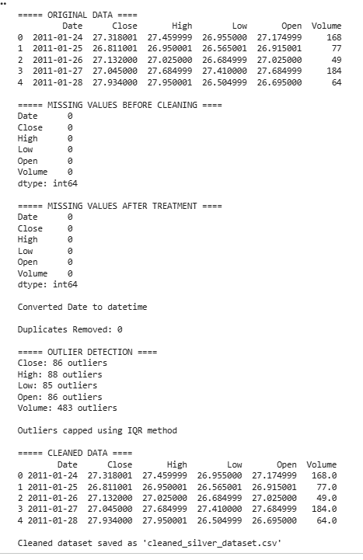
Conclusion:
Data cleaning improved dataset quality and consistency. Missing values and duplicates were handled effectively. The dataset is now ready for further analysis. Clean data ensures accurate results

